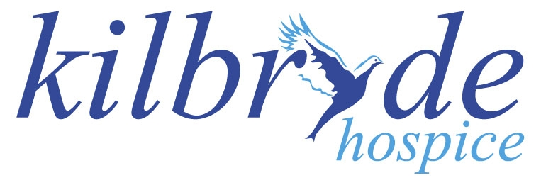
Gift Aid Declaration

Please Treat:

□ Just the enclosed gift of £_______________________ as a Gift Aid Donation;

□ All gifts of money that I make today and in the future as Gift Aid Donations;

□ All gifts of money that I have made in the past 3 years and all future gifts of money that I make from the date of this declaration as Gift Aid Donations.

(Please tick the appropriate box)

You must pay an amount of income tax and / or capital gains tax in each tax year at least equal to the tax that the charity will claim from HM Revenue & Customs on your Gift Aid Donation(s).

Donor’s Details

Title ________ Forename(s) _________________________ Surname __________________________

Home Address _______________________________________________________________________

___________________________________________________________________________________

Post Code ________________________________________ Date______________________________

Email ______________________________________________________________________________

Signature ___________________________________________________________________________

Please notify the charity if you:
- Wish to cancel this declaration
- Change your name or home address
- No longer pay sufficient tax on your income and/or capital gains

Tax claimed by the charity
- The charity will reclaim 25p of tax on every £1 you gave on or after 1 January 2010.

Kilbryde Hospice - Scottish Charity Number 032424, Company No: 224366
Kilbryde Hospice | McGuinness Way | East Kilbride | G75 8GJ

